

South Coast Future Ready Discussion Paper
  - Building a brighter future for Victor Harbor and the surrounding region starts now


Acknowledgement of Country
The City of Victor Harbor acknowledges the Ramindjeri and Ngarrindjeri people as the Traditional Custodians of the land and surrounding waters where we live and work.
We acknowledge their deep connection to Country and pay our respects to Elders past, present and emerging. This respect is extended to Aboriginal and Torres Strait Islander people across Australia.

Contents

Acknowledgement of Country 1
Contents 1
Snapshot of the Future Ready Discussion Paper 1
Introduction 3
Background 4
Strategic Context 5
Understanding Council’s Role 6
Key Focus Areas 7
Housing Affordability and Diversity 8
Economic Diversification 10
Education and Career Pathways 11
Liveability and Cultural Vibrancy 12
Engagement and Belonging 14
How To Get Involved 15

Snapshot of the Future Ready Discussion Paper

If you only read one page…start here!
We know that not everyone has the time to read a full discussion paper. This page gives you a quick, easy overview of what the South Coast Future Ready Strategy is all about, why we’re talking about it, and how you can get involved.
If something here catches your eye, you can dive deeper into the full discussion paper – but you don’t need to read it all to make a meaningful contribution.

Why This Matters
The Fleurieu Peninsula’s South Coast – from Victor Harbor to Goolwa - is growing and changing. The South Coast Future Ready Strategy will strive to keep our community balanced, diverse and sustainable.

What Evidence Tells Us
The following is a snapshot of the South Coast.
- Our community is growing fast 28,947 residents today – 10% growth in last five years Why it matters: We need to plan now to manage future demand for homes, services and infrastructure.
- A larger older population 43% of residents are 65+ (SA: 20%) Why it matters: Service demand is rising and will continue to increase.
- A mature community profile Median age: 62 years (SA: 41) Why it matters: We need age-friendly environments and strong health and community support systems.
- Big growth expected Over 50,000 residents in the South Coast by 2050 Why it matters: Growth at this scale will shape how we plan housing, jobs, transport and services.
- A shrinking workforce base Only 21% aged 15–44 (SA: 39%) Why it matters: Workforce shortages affect local business, health services and future economic growth.
- Fewer people in the labour force 42% workforce participation (SA: 60%) Why it matters: The local economy needs more workers, skills and job pathways.
- Higher support needs 10% need daily living support (SA: 6.7%) Why it matters: Health, wellbeing and support services must expand as the population ages.
- Housing is getting harder to access House prices doubled since 2020; rent up from $290 to $530/week Why it matters: Housing availability and affordability impact workforce retention, families and community wellbeing.
- Many renters are struggling 46% of renters in housing stress (SA: 31%) Why it matters: A more diverse housing mix is needed to support people across all life stages.
- A great place to live 71/100 liveability score (above national average of 69)* Why it matters: The Strategy aims to protect the lifestyle, environment and sense of community people value. * Australian Liveability Census City of Victor Harbor, 2023

Key Focus Areas
This discussion paper is centred around five key focus areas.
- Housing Affordability and Diversity - Homes for every stage of life and income
- Engagement and Belonging - A community where everyone belongs and leadership is cultivated
- Economic Diversification - Secure jobs in diverse industries
- Liveability and Cultural Vibrancy - Strong services, appropriate facilities, valued environment
- Education and Career Pathways - Local training linked to local career paths

Co-designing a Response with our Community
We know that this strategy will only be successful if it is shaped by the people who know our community best – you! We want this to be a strong collaboration, where our community’s lived experience, local knowledge and fresh ideas guide the decisions we make.
This strategy isn’t being written about our community – it’s being created with our community.
Throughout this process we’ll be asking for your thoughts on what’s working well, what needs attention and what are the opportunities for the future. Whether you are a young person, a family, retiree, business owner or new arrival to our community, your voice matters.
There are lots of ways to get involved from completing a survey to talking with us at one of our community pop-ups.
Find out more about how you can get involved online at www.yoursay.victor.sa.gov.au or talk with one of the project team by calling (08) 8551 0500.

Introduction
Victor Harbor and the surrounding region is changing. The choices we make today will shape the community we become tomorrow. As more people discover our coastal lifestyle and strong sense of community, our population continues to grow and evolve. This growth brings opportunities, but it also places pressure on services, housing and infrastructure, especially as our community continues to age.
We’ve heard clearly from our community that growth needs to be managed carefully to protect what makes our region special – our natural environment, relaxed lifestyle, heritage and strong community spirit.
National and state research reinforces the importance of planning for a balanced and diverse population which helps keep communities economically resilient and socially connected.
- Planning for Australia’s Future Population emphasises the importance of balanced population structures for long-term service sustainability.
- South Australia’s Population Projections 2021–2051 highlight the need for diverse and inclusive communities to support employment and infrastructure needs.
- The Regional Australia Institute’s Big Movers 2023 report shows that regional centres with a mix of younger families, skilled workers and culturally diverse residents experience stronger workforce participation and business growth.
The South Coast Future Ready Strategy will translate these ideas into practical actions for Victor Harbor and the broader region. Its purpose is to:
- strengthen population balance
- support workforce access and local opportunity
- protect what we value most
- build a resilient and sustainable future for everyone.
This discussion paper shares the key issues shaping the region’s future and invites your feedback. Your ideas, stories and experiences will play a central role in guiding this strategy.

Background
The Fleurieu Peninsula’s South Coast continues to grow steadily. The 2021 Census recorded 28,947 residents across communities from Victor Harbor to Goolwa – a 10% increase since 2016 – with recent estimates placing our population at 31,798. This growth has been consistent at around 2% annually.
But it’s not just the size of our community that is changing, it’s the mix of people who live here. The South Coast has one of the oldest age profiles in Australia, with a median age of 62 and more than 43% of residents aged over 65. If growth trends persist and no intervention occurs, the median age for the South Coast could reach 67 by 2050. At the same time, there is a smaller proportion of young adults and families compared with South Australia overall. Household types reflect this pattern, with many couples without children and older people living alone.
An ageing population brings enormous strengths – wisdom, leadership, volunteering and strong community involvement. But a population that is heavily weighted toward older age groups can make it harder to sustain a strong workforce, maintain essential services and support long-term economic vibrancy.
Housing trends reinforce this challenge. Median house prices have almost doubled since 2020 and rental stress affects nearly half of local renting households. Most homes are three-bedroom detached dwellings, even though many households comprise 1-2 people. Further, a high number of properties are unoccupied holiday homes.
There is also a growing number of over 50’s lifestyle villages being developed. In Victor Harbor the number of dwellings in these types of villages is around 750 with more than 580 additional dwellings approved for future development. While these developments can provide housing options for older residents, their rapid expansion has broader implications for housing diversity, affordability, and local government sustainability, especially in a region already characterised by an ageing population and a limited supply of housing suited to younger workers and families.
Within our region, healthcare demand is rising, workforce participation is well below the state average, and many local jobs are part-time. Without more young workers and families, these pressures will intensify over time.
Long-term projections show Victor Harbor’s population could grow from 17,124 currently to between 25,000 and 36,000 by 2051. As the primary regional hub for the Southern Fleurieu, providing major health, education, retail, community and emergency services for a catchment far beyond its boundaries, the broader region could conservatively reach a combined population of around 70,000 by 2051. Without action, this growth would continue to be concentrated among older age groups. The Strategy aims to support a more balanced demographic profile, ensuring Victor Harbor can remain sustainable, resilient and functionally equipped to fulfil its broader regional role.

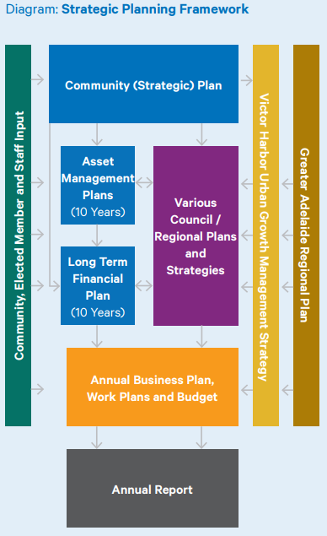
Strategic Context
The South Coast Future Ready Strategy aligns with several existing plans that guide Victor Harbor’s future.

Community Plan 2030
Our community’s long-term vision is for Victor Harbor to be “a place of choice to live, work, invest and visit”. The Strategy supports this vision by focusing on population balance, workforce sustainability and community wellbeing.

Victor Harbor Urban Growth Management Strategy 2025
The Victor Harbor Urban Growth Management Strategy provides a long-term blueprint for how Victor Harbor should grow while protecting its character and natural environment. It also identifies the development of the Future Ready Strategy as a priority, recognising the need to attract younger people and families.

Economic Development Strategy 2020–2030 and Investment Attraction Strategy 2024–2027
These strategies aim to build a resilient, diverse and growing local economy. The Future Ready Strategy complements this by focusing on people – the workers, families and entrepreneurs who drive economic activity.

Greater Adelaide Regional Plan
The Greater Adelaide Regional Plan sets out how housing, land use and jobs will be planned across the region to 2051. Victor Harbor is identified as a “satellite city”, expected to accommodate a significant share of future residential growth. The Future Ready Strategy aims to ensure this growth is sustainable and supports community needs.

Understanding Council’s Role
Everything Council does plays a part in shaping Victor Harbor’s future – from planning, infrastructure delivery, community programs, partnerships and advocacy. The way we approach different issues is influenced by many different factors including legislation, community expectations, available funding and capacity. Some outcomes sit directly within Council’s control. Others are delivered in partnership with the State Government, community organisations or the private sector. The planning system sets important rules about land use and development, but it also provides opportunities for Council to guide how growth occurs, advocate for improvements, and ensure local priorities are reflected in regional and state decision-making.
As we explore options for the Future Ready Strategy, it’s important to consider not just the potential benefit of each idea, but also what it would take to put it into action. Finding the right balance between impact and resources will help ensure the Strategy is both ambitious and achievable.
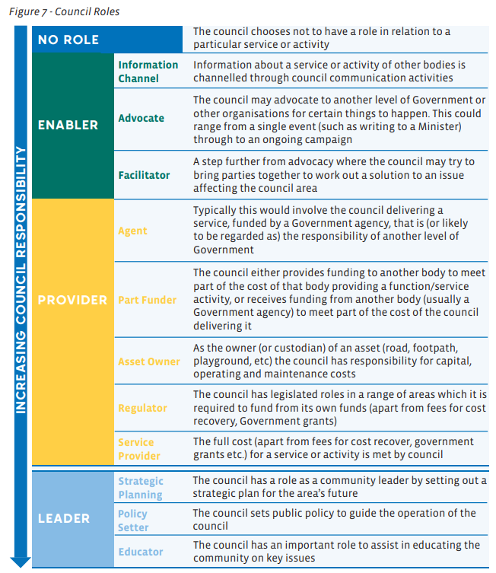

At a broad level, local governments are facing increased challenges in managing the pace, location and form of urban growth. While councils play an important role in setting local strategic direction and delivering community infrastructure, many of the most significant levers that shape growth sit with other stakeholders. Federal and State Governments set housing targets, planning rules, building standards and infrastructure priorities, while utility providers and the development industry determine the timing and feasibility of service delivery and development outcomes. Together, these forces can drive growth patterns that are not always aligned with local community aspirations or Council’s long-term vision.
Given these constraints, the Future Ready Strategy recognises the need for Council to explore more innovative and adaptive approaches to managing growth. This includes strengthening advocacy, improving collaboration with State agencies and infrastructure providers, and using strategic planning tools to influence outcomes where direct control is limited. By focusing on what Council can control and influence, we can better protect against unplanned or poorly sequenced growth and work towards a more sustainable, equitable and resilient future for Victor Harbor.

Key Focus Areas
Feedback collected through the Urban Growth Management Strategy and other engagement has helped identify five key areas for discussion:
- Housing affordability and diversity
- Economic diversification
- Education and career pathways
- Engagement and belonging
- Liveability and cultural vibrancy
The following sections describe the current situation, our goals, and possible actions for each focus area, along with questions to help guide your feedback.
What do you think of the five key focus areas guiding this discussion paper? Is there anything missing?

Housing Affordability and Diversity

Current Situation
Victor Harbor and the South Coast’s appeal as a coastal destination about an hour’s drive from the Adelaide CBD means the demand for housing is high. However, supply is limited and often mismatched to community needs.
- 87% of homes are detached houses
- Most have three bedrooms or more
- Only 19% of homes are rentals
- Median house prices have risen from $380,000 to $730,000 since 2020
- A significant number of dwellings (22%) are unoccupied as holiday homes
Environmental constraints such as coastal hazards, bushfire risk and limited vacant land mean a significant portion of future housing will need to occur through infill and redevelopment within existing neighbourhoods. The Victor Harbor Urban Growth Management Strategy highlights the importance of well-located, well-designed infill housing that maintains Victor Harbor’s character.
Employers report that the lack of affordable housing options makes it difficult to attract and retain workers, especially in health, aged care, education, hospitality and tourism.

Our Goal
Create a diverse and affordable housing mix that supports residents at all stages of life, strengthens the local workforce, and protects the region’s character and environmental values

Types of Actions to Consider
The following are a broad range of actions that Council could explore with the community and other partners. They are just a starting point – not a complete list – so we’d like to hear your ideas too.
- Review planning policies to support more diverse housing options close to shops, services and transport.
- Work with the State Government and regional partners to improve long-term housing availability.
- Explore partnerships for key-worker or affordable housing models.
- Investigate opportunities to use, lease or partner on suitable Council land to support housing needs.
- Consider ways to balance visitor accommodation with the needs of permanent residents.
- Encourage high-quality infill development that respects neighbourhood character.
- Purchasing and/or encumbering land, with the consent of the landholder, to take back planning influence and control and to limit the rapid construction of further Over 50s retirement villages being built.

Share Your Experience and Ideas
- What is your experience finding a place to live in Victor Harbor?
- What level of involvement should Council have in land purchase / development or partnership to influence long-term housing and land-use outcomes?
- What types of housing do you think Victor Harbor needs more of (e.g. townhouses, units, accessible homes, smaller homes, family homes, student accommodation, worker housing)?

Economic Diversification

Current Situation
Victor Harbor plays an important role as the service hub for the southern Fleurieu Peninsula. As the largest township in the area, it provides essential amenities such as major supermarkets, medical facilities, schools, government services, and professional businesses that smaller surrounding communities rely on.
Victor Harbor’s demographic profile also impacts the local economy. A large retiree population contributes strongly to volunteering and civic life, but workforce participation is low (40% compared with 60% for SA). Local jobs are mostly in health care, retail, tourism, hospitality and agriculture. Most businesses are small or micro-enterprises.
Young people often leave the region for study or work and may not return due to limited career progression, higher-skilled jobs, or diverse industry options. At the same time, remote work and digital connectivity present new opportunities for start-ups, creative industries and professionals who could live and work locally.

Our Goal
To build a resilient and diverse local economy with secure job opportunities across a wide range of industries, supporting people of all ages to live, work and thrive on the Fleurieu Peninsula’s South Coast.

Types of Actions to Consider
The following are a broad range of actions that Council could explore with the community and other partners. They are just a starting point – not a complete list – so we’d like to hear yours too.
- Strengthen partnerships with local businesses and industries to understand skills needs and growth opportunities.
- Support entrepreneurship, small businesses and innovation.
- Explore opportunities for digital infrastructure, co-working spaces and remote work hubs.
- Promote career pathways in key sectors like health, trades, tourism and emerging industries.
- Attract new industries and investment that complement Victor Harbor’s strengths.

Share Your Experience and Ideas
- What barriers make it hard for businesses to grow and operate?
- What could be done to create an environment that supports innovation, entrepreneurs, and start-ups to thrive?
- What industries do you think could help strengthen our economy?
- What kind of jobs do you hope will be available here for future generations?

Education and Career Pathways

Current Situation
Education and training opportunities in Victor Harbor are improving, thanks to strong schools and the expanding Fleurieu Study Hub and TAFE SA programs. These play an important role in supporting local industries and giving residents more ways to learn close to home.
Despite this, many young people still feel they need to leave Victor Harbor to get the qualifications or experience they want. Once they go, it can be hard to return due to limited career opportunities or progression pathways.
Feedback from local businesses shows ongoing challenges in attracting and retaining skilled workers, highlighting the need for stronger links between education providers, employers and the community.
For adult learners and career changers, flexible study and training options remain important. Increasing these opportunities would help support both workforce needs and community aspirations.

Our Goal
Ensure that people of all ages have access to quality education and meaningful career pathways without needing to leave the region.

Types of Actions to Consider
The following are a broad range of actions that Council could explore with the community and other partners. They are just a starting point – not a complete list – so we’d like to hear yours too.
- Council facilitates partnerships between schools, TAFE, the Study Hub and local businesses.
- Improve awareness of local study, training and adult learning options.
- Explore more opportunities for work experience, internships and apprenticeships.
- Promote Victor Harbor as a great place to live, study and work.
- Support young people and early-career professionals to stay or return after study.
- Seek opportunities to help Victor Harbor become a University City.

Share Your Experience and Ideas
- What has your experience been with education, training or career opportunities in Victor Harbor?
- What would help attract and retain working age people in the region?
- What would strengthen pathways to local education opportunities and jobs?
- What new training providers or university partnerships would benefit the community?

Liveability and Cultural Vibrancy

Current Situation
Victor Harbor rates strongly for overall liveability (71/100 – above the national average of 69), with residents valuing safety, community spirit, local services and the natural beauty that surrounds us. Our coastline, open spaces and environmental features play an important role in how people experience daily life and connect with the place they live. At the same time, Victor Harbor has relatively limited evening and after-hours activities, which can make it harder for younger people, working families and early-career professionals to feel connected and engaged in the community. Strengthening evening activities plays a role in attracting and retaining a balanced population and supporting ongoing workforce needs.
There are growing gaps in essential services such as healthcare, childcare, youth recreation, evening activities and accessible public spaces. The City of Victor Harbor’s Social Infrastructure Assessment highlights challenges in accessing services like bulk-billing GPs, a 24-hour pharmacy and urgent care options. Public transport, mobility and the way people move around the city also influence how easily residents can enjoy everything Victor Harbor has to offer.
As our population grows and changes, protecting the quality of our environment, supporting a diverse range of services and strengthening the facilities our community relies on will all be important to maintaining and improving our liveability.

Our Goal
To support a high quality of life by strengthening the services, facilities and cultural experiences our community relies on, while protecting the natural environment that makes Victor Harbor and the South Coast area such a great place to live.

Types of Actions to Consider
The following are a broad range of actions that Council could explore with the community and other partners. They are just a starting point – not a complete list – so we’d like to hear your ideas too.
- Advocate for improved local health, childcare and community services.
- Invest in parks, trails, sport and recreation facilities designed for all ages.
- Support cultural programs, public art and activation of community spaces.
- Expand entertainment, dining and social offerings for a wider range of ages.
- Improve travel and transport options to support daily life.

Share Your Experience and Ideas
- What aspects of local life do you most value in Victor Harbor and what could be improved?
- Are there services or facilities you feel are missing or under-provided?
- How could travel and transport options improve your daily life?
- What does a liveable and vibrant Victor Harbor look like to you in the future?

Engagement and Belonging

Current Situation
Victor Harbor’s community spirit is one of its greatest strengths, and many residents feel connected through volunteering, sport, arts, local groups and informal networks. But as our population changes, with more new residents arriving and younger people moving here or returning, the way people connect is also changing.
We know that some groups don’t feel as involved or represented. Younger residents often say that decision-making processes don’t reflect their ideas or priorities. New arrivals can struggle to find clear pathways to information, services or social opportunities, and some people find it hard to build connections without existing networks.
Communication and accessibility also play a big role. Not everyone uses the same platforms, has access to transport, or feels comfortable in traditional engagement settings. Strengthening belonging means creating more flexible, inclusive and modern ways for people to take part, whether that’s through social activities, volunteering pathways, leadership roles or community-led initiatives.

Our Goal
Foster a welcoming, connected and inclusive community where people of all ages and backgrounds feel they belong and can participate in shaping local life.

Types of Actions to Consider
The following are a broad range of actions that Council could explore with the community and other partners. They are just a starting point – not a complete list – so we’d like to hear yours too.
- Make engagement more accessible and youth friendly.
- Improve communication and “welcome” information for new residents.
- Support volunteering pathways that suit different ages and lifestyles.
- Strengthen opportunities for leadership development across the community.
- Increase activation of community spaces for social connection.

Share Your Experience and Ideas
- How do you participate in the local community, and what makes you feel connected?
- Are there particular groups of people who you think feel less included or represented in Victor Harbor? What makes it harder for them?
- What opportunities or initiatives would help grow local leadership and community involvement?

Have your say
Whether you are a long-term resident, new to the area, a business owner, a young person or a family – your experience and ideas will help shape a practical set of actions to guide our region forward.
How to get involved
- Complete our survey online at www.yoursay.victor.sa.gov.au/future-ready before 5pm on Friday, 27 February 2026.
(hard copies available from the Civic Centre – 1 Bay Road, Victor Harbor).
The project team will also be out and about at community events during January and February, be sure to drop by for a chat if you see us!
If completing the survey is difficult, feedback can also be provided by phone, email, or in person at a listening post.
One-on-one or small-group conversations can be arranged where this is a more accessible way to participate.
For more information about the South Coast Future Ready Strategy visit www.yoursay.victor.sa.gov.au/ future-ready, call (08) 8551 0500.

